**Patient Monitoring for Safe Transfers and Limb Repositioning using Standard WebCam with OpenCV and Tensorflow in real time**

OpenCV on web

Heart rate Feature 1

Respiration rate 2

Formula to calculate Blood pressure and oxygen saturation(search)

Blood Pressure

When your doctor takes your blood pressure, it's expressed as **a measurement with two numbers, with one number on top (systolic) and one on the bottom (diastolic)**, like a fraction. For example, 120/80 mm Hg.

MAP = SBP + 2 (DBP)

Oxygen Saturation

SO2 = (23,400 * (pO23 + 150 * pO2)-1 + 1)-1

## **How the processes works**

A preview for 30 seconds of recording will be processed frame by frame to get the intensities of RBG colors on each frame.

(Heart rate)

Red and Green intensities will be stored in an array that will be applied on a Fast Fourier Transform, on the resultant array the highest peak after neglecting the noise which will be on the first few stored data will contain the frequency of the heart rate on 1 second, after that the heart beat will be estimated. (Fft)

(Blood pressure)

After estimating the heart rate, blood pressure can be estimated by using some equation which will be mentioned in the references.

(Respiration Rate)

Same as Heart Rate, the difference is a bandpass filter must be applied from 0.1 Hz to 0.4Hz with 0.2Hz center frequency to get the Respiration rate. (Fft2)

(Oxygen Saturation Level)

Ac and Dc signals must be obtained from the PPG signal. Dc signal is the mean values of the Red and Blue intensities for the whole period of time, while the Ac Signal is the Standard Deviation and it can be calculated as follows from here : <https://en.wikipedia.org/wiki/Standard_deviation>

3D Pose Estimation

# [BlazePose GHUM 3D](https://discuss.tensorflow.org/t/blazepose-ghum-3d-transfer-learning/4527)

https://medium.com/axinc-ai/blazepose-a-3d-pose-estimation-model-d8689d06b7c4

From Tensorflow

Using tensor flow’s B[lazePose GHUM 3D](https://discuss.tensorflow.org/t/blazepose-ghum-3d-transfer-learning/4527) model to detect emotions, to see if a patient has fallen or not.

Limb Repositioning:- Tracking joints for safe movement depending upon the flexibility of the person to assist people with disabilities.

Patient Transfers:- Tracking joints and the full body pose for safe transfer of wheelchair to bed or bed to wheelchair.

Questions

1. How many key points does BlazePose GHUM 3D model have?, What are the 33 key points?

33 (x,y,z) key point objects

1. What are the average ranges of joints for humans?

250 – 350 joints

1. How can we coordinate the 2D joints and the 3D pose?

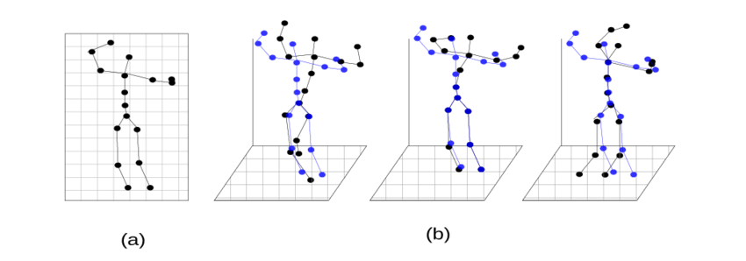

# (a) 2D position of joints, (b) Different 3D pose interpretations of the same 2D pose. Blue points represent the ground truth 3D locations of joints while the black points indicate other possible 3D interpretations. All these 3D poses project to exactly same 2D pose depending on the position and orientation of the camera projecting them onto 2D plane.

1. Display the 3d model on a webpage?

https://www.smoothie-3d.com/site/page_index.php

It can be used to create a 3d model from 2d images

3D Scanning is the process of using multiple 2D images or photographs to create a 3D model. For example, Sketchfab users scan their dinners, cars, or even statues in museums. You can do this with a professional-level camera or even your smartphone!

[Trnio](http://www.trnio.com/): A cheap, easy-to-use iOS app. Includes native Sketchfab and Facebook sharing.

* [Scann3D](https://play.google.com/store/apps/details?id=com.smartmobilevision.scann3d&hl=en_US): A free, easy-to-use, Android app. Includes native Sketchfab sharing.
* [Agisoft Metashape](http://www.agisoft.com/): High quality, commercial Windows and OS X desktop app. Includes native Sketchfab sharing.
* [Autodesk ReCap 360](https://www.autodesk.com/products/recap/free-trial): Windows-based software with a free 30-day trial
* [RealityCapture](https://www.capturingreality.com/Product): A state-of-the-art all-in-one photogrammetry software with [native Sketchfab integration](https://help.sketchfab.com/hc/en-us/articles/217919123-RealityCapture)
* [3DF Zephyr](https://www.3dflow.net/3df-zephyr-feature-comparison/): A freemium, user-friendly scanning desktop app for Windows. Includes [native Sketchfab sharing](https://www.3dflow.net/technology/documents/3df-zephyr-tutorials/uploading-directly-to-sketchfab/).

We can use Three.js to create 3d model on a webpage ,by just loading the model into the script

Tasks:

Collect videos of patients being transferred from the bed to the wheelchair.(Single person)

<https://www.youtube.com/watch?v=CfvLWeoytdw> (1:00 to 1:04)(entire pose of human body)

Task:- Slice the seconds mentioned from the video

Find a 3d model to display (mixamo) (The 3d model should move in conjunction with the 3D pose Key Points from the model)

Skeleton-Based Model: First and foremost, the skeleton model is commonly used in 2D human pose estimation ([Cao et al., 2018](https://www.sciencedirect.com/science/article/pii/S1077314221000692" \l "b17)) and is naturally extended to 3D. The human skeleton model is treated as a tree structure, which contains many [keypoints](https://www.sciencedirect.com/topics/engineering/keypoints) of the human body and connects natural adjacent joints using edges between key joints, as shown in [Fig. 5](https://www.sciencedirect.com/science/article/pii/S1077314221000692" \l "fig5).(First Step)

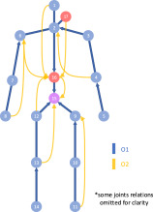

SMPL-Based Model: For the shape model, recent works use the skinned multi-person linear (SMPL) model ([Loper et al., 2015](https://www.sciencedirect.com/science/article/pii/S1077314221000692" \l "b75)), as shown in [Fig. 6](https://www.sciencedirect.com/science/article/pii/S1077314221000692" \l "fig6), to estimate 3D human body joints ([Bogo et al., 2016](https://www.sciencedirect.com/science/article/pii/S1077314221000692" \l "b15)). The human skin is represented as a triangulated mesh with 6890 vertices, which is parameterized by shape and pose parameters. The shape parameters are used to model the body proportions, height and weight, while the pose parameters are used to model the determined deformation of the body. The 3D pose positions can be estimated by learning the shape and body parameters. (Choosen)(Second Step)

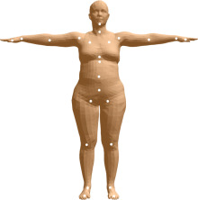

[https://app.theconstructsim.com/#/](https://app.theconstructsim.com/" \l "/)

<https://blog.tensorflow.org/2021/08/3d-pose-detection-with-mediapipe-blazepose-ghum-tfjs.html>

Building a Human URDF

Autodesk 3DSmax

Student Autodesk

Computer